AFC Diagram

|  |
| --- |
| ISD.VN.20191-09 |

**Biểu đồ use case của hệ thống soát vé tự động**

**Biểu đồ lớp của hệ thống soát vé tự động**

**Các biểu đồ cho từng Usecase**

1. **Sequence diagram**
2. **[Nguyễn Mạnh Tiến] Enter with one-way ticket**

1. **[Nguyễn Mạnh Tiến] Exit with one-way ticket**

1. **[Phạm Hữu Thọ] Enter with prepaid card**

1. **[Nguyễn Đình Thơ] Exit with prepaid card**

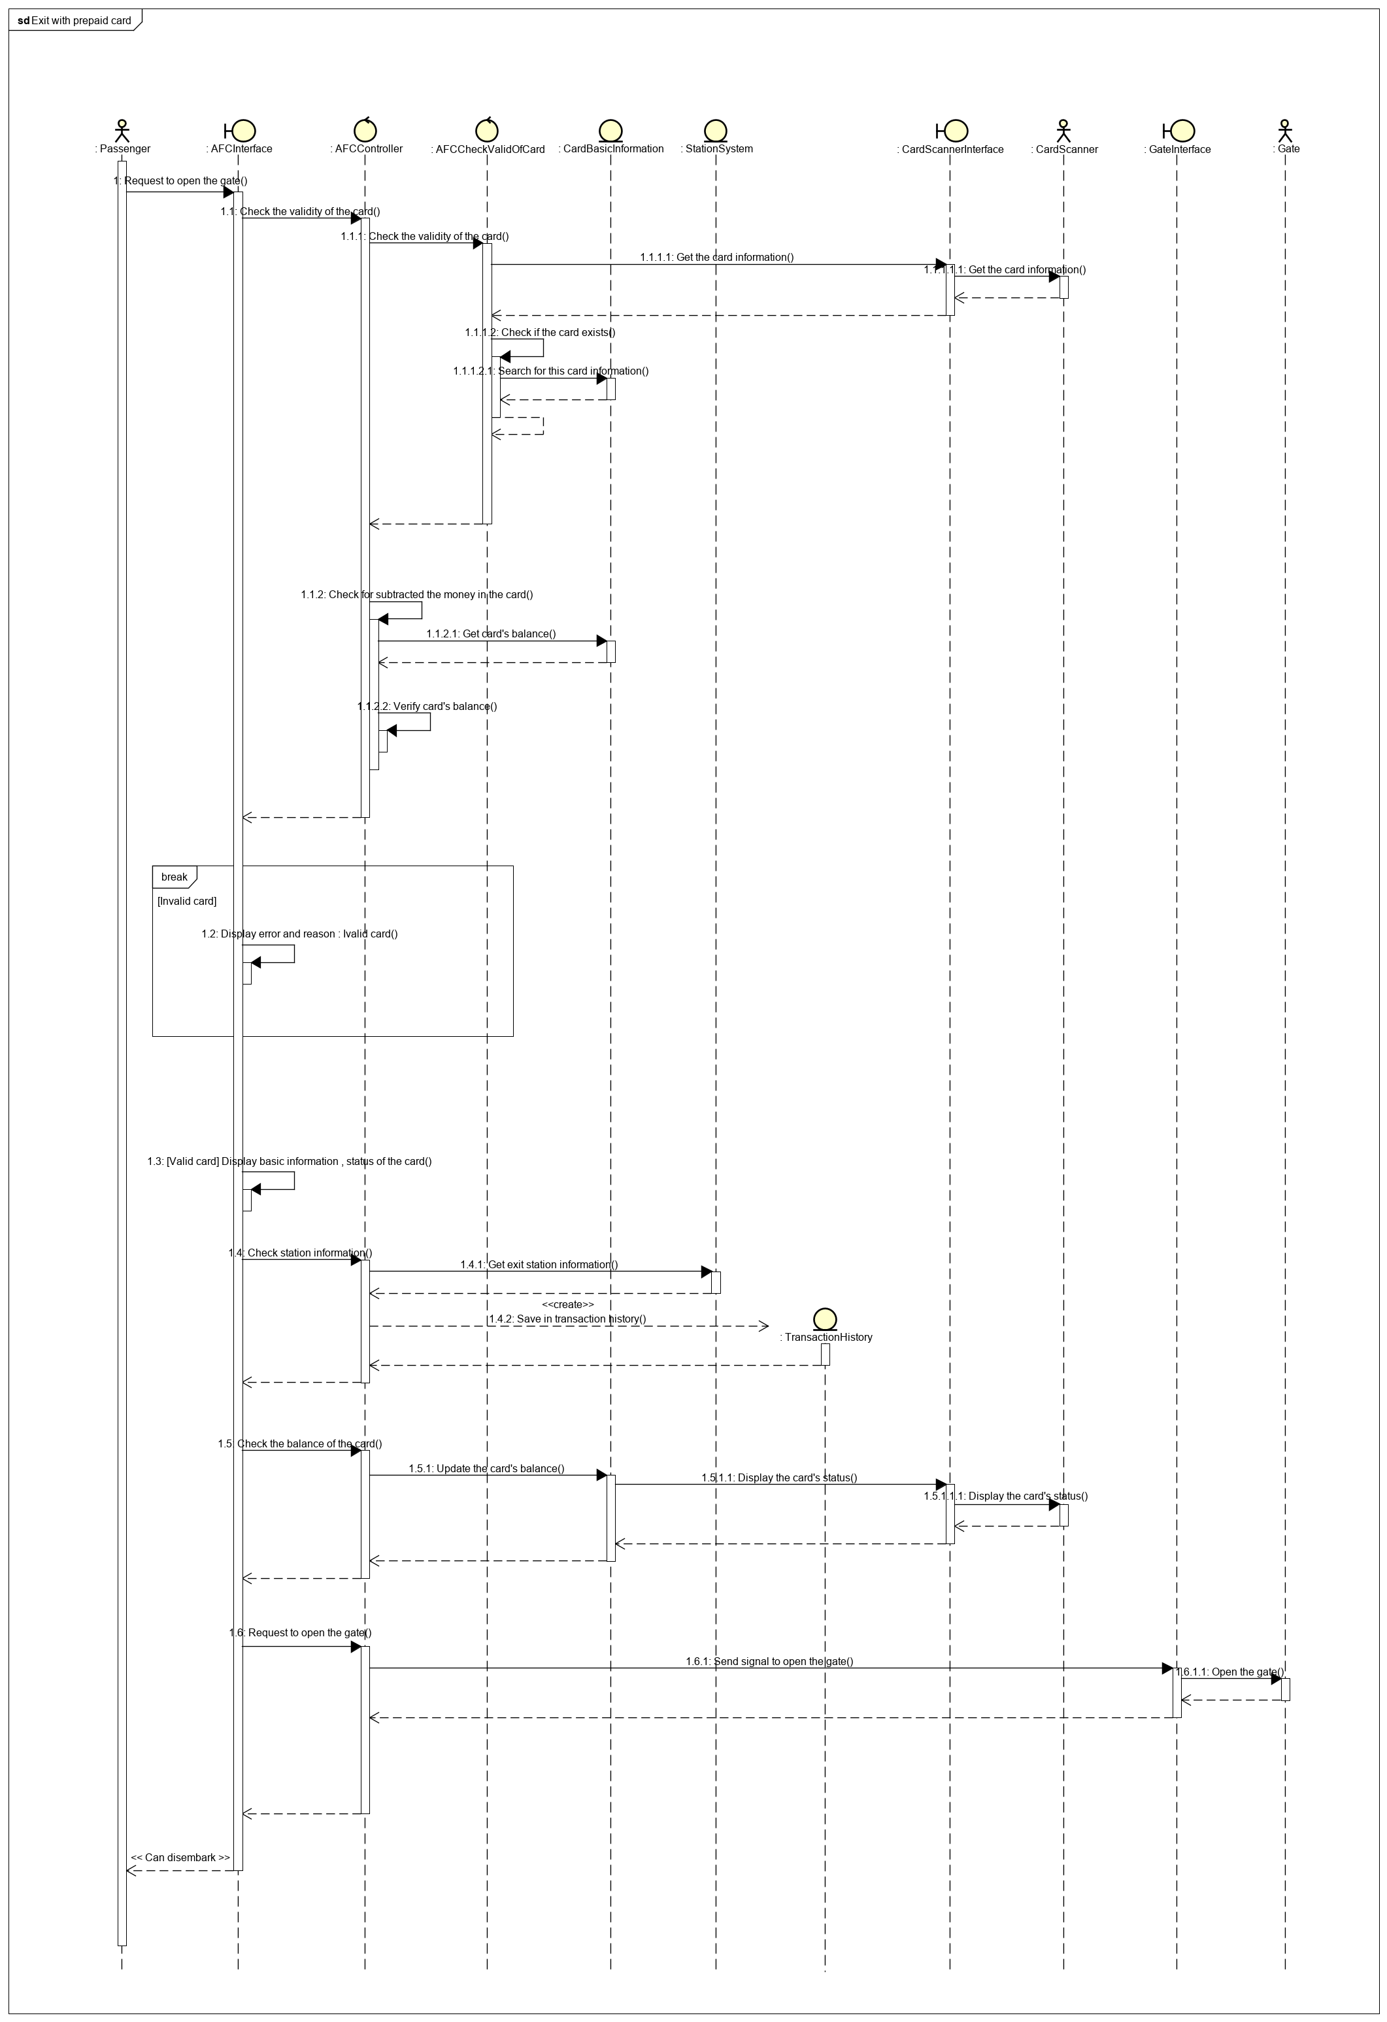

1. **[Phùng Thị Trang] Enter with 24-hour ticket**

1. **[Trần Văn Thông] Exit with 24-hour ticket**

1. **Communication diagram**
2. **[Nguyễn Mạnh Tiến] Enter with one-way ticket**

1. **[Nguyễn Mạnh Tiến] Exit with one-way ticket**

1. **[Phạm Hữu Thọ] Enter with prepaid card**

1. **[Nguyễn Đình Thơ] Exit with prepaid card**

1. **[Phùng Thị Trang] Enter with 24-hour ticket**

1. **[Trần Văn Thông] Exit with 24-hour ticket**

1. **Class diagram**
2. **[Nguyễn Mạnh Tiến] Enter with one-way ticket**

1. **[Nguyễn Mạnh Tiến] Exit with one-way ticket**

1. **[Phạm Hữu Thọ] Enter with prepaid card**

1. **[Nguyễn Đình Thơ] Exit with prepaid card**

1. **[Phùng Thị Trang] Enter with 24-hour ticket**

1. **[Trần Văn Thông] Exit with 24-hour ticket**

